Data Science vs Artificial Intelligence

We may have often heard the terms Data Science and Artificial Intelligence (AI) used interchangeably, which might have led to us being quite confused about the alternating use of these terms, their applications to real-world problems, and also for learning the concepts. The common entity between Data Science and Artificial Intelligence is data. While one might suggest AI and Machine Learning might come under the broad bucket of Data Science, there are subtle thin line differences that we shall be looking into as we proceed further in this article.

Is Data Science really the best job of the 21st Century?

For most of the tech giants around the globe, these terminologies, along with their respective skill sets, fall into the top priority requirements amongst their recruitments and look out for Data Science professionals. Data Scientists, also touted as the "sexiest job of the 21st century", have seen job postings for it rise by 256% on Indeed over the year 2019.

Experts have also suggested that, by the year 2030, AI and Data Science will see a 31.4 percent increase in job openings which will be mostly based on Artificial Intelligence. The field of Artificial Intelligence has seen a massive increase in its applications over the past decade, bringing about a huge impact in about many fields such as Pharmaceutical, Retail, Telecommunication, energy, etc. and

**Data Science's** prime focus is to engineer, process, interpret and analyze the data to make effective and informed decisions. **Artificial Intelligence,** on the other hand, is to enable computers to behave as humans and perform intellectual tasks such as problem-solving, decision-making, and understanding perception and human communication. Understanding [Data Science course eligibility](https://www.knowledgehut.com/data-science-courses) for [data science BootCamp course](https://www.knowledgehut.com/data-science/data-science-bootcamp-training).

With this, we shall start with deep diving into each of these domains to understand each of these terms, their underlying concepts, the differences amongst them, and what makes the other better for each of their applications. This will help us to differentiate clearly amongst these domains

# What is Data Science?

To simply put, Data Science is a vast domain of study that generally deals with great volumes of data to identify patterns (seen or unseen), generate findings, and derive meaningful information and insights, which will, in turn, help us make informed decisions and plan strategies accordingly. The insights that are generated through this process of Data Science can enable businesses to identify new opportunities, increase operational efficiency and effectiveness, improve their current strategies to grow their portfolio, and strengthen their position in the market. A course with [practical data science with python](https://www.knowledgehut.com/data-science/data-science-with-python-certification-training) or [Python with Data Science](https://www.knowledgehut.com/data-science/data-science-with-python-certification-training) can help.

Data Science initiatives from an operational standpoint help organizations optimize various aspects of their business, such as supply chain management, inventory segregation and management, demand forecasting, etc. It enables companies to focus on creating business strategies and plans which are based on thorough data analysis on customer behavior, market trends, and competition. Essentially we can conclude by mentioning that a company will be missing out on a world of opportunities and end up making flawed decisions without the application of data science to their business.

Data Science also finds applications beyond regular business operations as well. It also has the highest potential to tackle many global issues that have been identified as the world's most pressing problems labeling them as Sustainable Development Goals (SDGs), where various government-funded research centers and business schools are taking up these issues to deal with a large amount of data to capture, analyze and utilize which in turn helps in creating products and services to tackle large scale fundamental global and human issues.

A data science lifecycle involves the following stages, which are achieved through various roles, tools, and processes.

* **Data Collection and Ingestion Stage:** The lifecycle begins with first collating relevant data required for the process. This data can be of any type, i.e., structured or unstructured, which also includes images, videos and social media, and more. Data collation can happen in formats such as a manual data entry process, scraping from the web, and real-time live streaming data from various sensors present on multiple systems and machinery.
* **Data Storage and preprocessing**: Once the data collation process is established by the organizations, it becomes necessary to store them in different storage systems based on their needs. The storage of data can happen either on on-premises devices or in the cloud, which are the two popular storage methods for any organization.   
    
  Once the storage process is realized, the next stage is to invest time in cleaning, deduplicating, transforming, and combining the data using data integration technologies which will enable easy ETL/ELT processes further. This stage becomes necessary as the data moves on to further analysis, and one wouldn't want to really spend a huge amount of time doing basic checks to clean the data
* **Analysis and generation of findings and insights:** The major aim of this stage is to make sense of the data and see what it is trying to tell. Exploratory Data Analysis can be performed to examine the data to identify patterns, distributions, trends, ranges, and biases. One very popular methodology to evaluate the data is to perform hypotheses testing on data, where one gets to build hypotheses and test them against the data to check their credibility.   
    
  This stage also leads to determining the relevance for use within modeling for various methods such as predictive analytics, machine learning, deep learning, etc. All these processes lead us to generate findings and insights which would enable one to make informed decisions
* **Communication:** What use are all the findings, insights, and recommendations gathered when they aren't put into use or process, right? So, here is the stage where all these insights are presented as reports with visualizations and other suitable formats that will enable the business to observe the value that can be derived, which in turn helps the decision-makers

Typical applications that we can list under the domain of data science are pattern recognition, anomaly detection, classification, predictive modeling, sentiment analysis, etc. This data science pipeline and its relevant tools and technologies become the core of all the responsibilities surrounding a data scientist's job descriptions.

# What is Artificial Intelligence?

Artificial Intelligence, at its core, is a branch of computer science that aims to replicate or simulate human intelligence in machines and systems. It is an interdisciplinary science with multiple approaches, and advancements in Machine Learning and deep learning are creating a paradigm shift in many sectors of the IT industry across the globe. Machine Learning and Deep Learning are typically mentioned in conjunction with Artificial Intelligence which is generally considered sub-fields of Artificial Intelligence. These streams basically consist of algorithms that seek to make either predictions or classifications by creating expert systems that are based on the input data.

There are two types of Artificial Intelligence that we will be talking about here in this section which is Weak AI and strong AI.

* **Weak AI,** which is also known as Narrow AI, is a format of AI that is majorly trained and focused on performing only specific tasks. Most of the AI that surrounds us today is an application of weak AI, such as Facebook's recommended newsfeed, Amazon's suggested purchases, Apple Siri, and Amazon Alexa, the technology that answers users' spoken questions. Even Email spam filters that we enable or use in our mailboxes are examples of weak AI where an algorithm is used to classify spam emails and move them to other folders.
* **Strong AI** is made of two components which are Artificial General Intelligence (AGI) and Artificial Super Intelligence (ASI). The AGI, or the general AI, in theory, is a form of AI where a machine would equal human intelligence, which would enable it to be self-aware and conscious, leading to the ability to solve problems, learn and strategize for the future. ASI, or superintelligence, is touted to surpass the human intelligence and abilities of the human brain. Strong AI is still entirely theoretical, and no practical examples are in use today. Researchers are still exploring its development and aim to create intelligent machines that are indistinguishable from the human mind.

There are numerous real-world applications of AI in today's world. A few of them are mentioned below here in this article are:

* **Speech Recognition**: Also called Automatic Speech Recognition (ASR), or speech to text, is a capability of Natural Language Processing (NLP) that processes human speech into a written format. Many mobile devices have incorporated speech recognition into their systems.
* **Computer Vision:** In this domain, digital images, videos, and other visual formats form the input for AI, which enables the computer to derive meaningful inputs based on which actions can be performed. Convolutional neural networks powers computer vision to find applications in photo tagging, radiology imaging in healthcare, etc.
* **Recommendation Engines:** AI algorithms can help to discover various trends within the past consumption data that will help the end users to develop efficient strategies for identifying cross-selling opportunities

Machine learning/Deep Learning is the study of the development of techniques for using data to enhance performance or inform predictions, while data science is the study of data and how to extract meaning from it. A subset of artificial intelligence is called machine learning. This is the key difference between data science and machine learning.

Now that we have had a brief introduction to these domains and their applications across different verticals of the business let us also try to understand the differencing factors amongst these fields of study. Let’s now look at the difference between ai and data science.

# Data Science vs. Artificial Intelligence

|  |  |  |  |
| --- | --- | --- | --- |
| **SI** | **Parameters** | **Data Science** | **Artificial Intelligence** |
| 1 | Basics | Involves processes such as data ingestion, analysis, visualization, and communication of insights derived. | It is an implementation of predictive models to quantify or classify future events and trends |
| 2 | Skills | Logical reasoning, programming knowledge, database management skills, and strong presentation skills to convey the insights in a meaningful manner | Strong foundation in Mathematics and Statistics along with programming knowledge, complex Machine Learning, and Deep Learning Algorithms and concepts |
| 3 | Goals | To identify hidden patterns within the data to generate meaningful findings and insights | The research goal of AI is to enable computers and machines to work intelligently. |
| 4 | Purpose | Utilize the derived findings and insights to make informed decisions | The purpose of AI is to provide software capable enough to reason on the input provided and explain the output |
| 5 | Types of Data | Different types of data can be used as input for the Data Science lifecycle. Structured, unstructured, and semi-structured data are the forms of input | Visual, textual, and Numerical data are the data formats that can be used to train algorithms under ML or DL within AI |
| 6 | Scientific Processing | It follows a typically fixed procedure of data science pipeline, which involves all the steps from data ingestion to the communication of insights. It requires a high degree of Scientific processing | The process followed here is to focus on the creation of a model object which can be fed into the models which generate outputs. Models are highly complex |
| 7 | Build | We can build complex models using the concepts of data science, which are purely based on statistics to find out facts about the data | Human understanding and cognition up to a certain level can be enabled using AI |
| 8 | Techniques Used | Statistical techniques and data analytics form the core of techniques used | Concepts of Machine Learning and Deep learning are extensively used |
| 9 | Tools Used | Popular tools used for DS are 1. SQL for data migration 2. Python libraries such as pandas, NumPy, plotly, etc. for data exploration and statistics and Visualization tools such as Power BI and Tableau | Tools are used for being able to run complex machine learning and deep learning algorithms |
| 10 | Knowledge | Data Mining, Data wrangling, Data Exploration and visualization, and programming concepts are necessary for this domain | Knowledge of Machine Learning and Deep Learning algorithms, along with mathematics and statistics, form the core of AI |
| 11 | Examples of Tools | SQL, R, and Python are among the popular tools used for Data Science | Examples of popular tools used are Scikit learn, TensorFlow, Caffe, etc. |
| 12 | Applications | Typical applications are Pattern recognition, Anomaly detection, classification, predictive modeling, sentiment analysis | Applications of AI include Speech recognition, computer vision, recommendation engines |
| 13 | Models | Models built here are for generating insights to aid decision making | AI models being much more complex in nature, aim to simulate human cognition |
| 14 | When to use | It can be used in scenarios like: | AI is used in scenarios where:  1. Automating repetitive behavior  2. Predicting/ Forecasting into the future with historical and current data |
| 1. Exploratory Data analysis  2. To deploy predictive models  3. To identify patterns and trends in the data |
| 15 | Examples | Examples of Data Science: 1. Increase sales using prediction of demand for the future 2. Effective campaign management through customer segmentation 3. Fraud Detection and prevention | AI is deployed in cutting-edge technologies such as: |
| 1. Speech recognition devices such as Amazon Alexa, Siri by apple |
| 2. Recommendation engines: Netflix watch suggestions, Amazon suggestions for product catalog |

## Difference in Job Roles across Data Science and Artificial Intelligence

Let us understand the artificial intelligence and data science job opportunities.

## Data Science

Let's start with Data Science by listing down and quickly understanding the different roles we see in it, which are:

### Data Analyst

Data Analysis consists of the process of data cleaning, analyzing, interpreting, and communicating the findings and insights through the correct set of visualizations and tools. A data analyst would be a professional who will be able to accomplish all the tasks mentioned in the process of data analysis. The role can also be defined as someone who has the knowledge and skills to generate findings and insights from available raw data.

The skills that will be necessarily required here will be to have a good foundation in programming languages such as SQL, SAS, Python, R. A

### Data Engineer

A professional who has expertise in data engineering and programming to collect and covert raw data and build systems that can be usable by the business. They also maintain these systems and datasets that are accessible and easily usable for further uses. They also look into implementing methods that improve data readability and quality, along with developing and testing architectures that enable data extraction and transformation.

Technical expertise with concepts such as data mining, data models, and segmentation is a necessity, along with a strong hold on SQL and working with databases.

### Data Scientist

Essentially, we can consider a data scientist as someone who can understand the challenges of business and offer solution approaches that are implementable by them. A Data scientist generally takes up all the tasks that are part of the data science pipeline and delivers findings and insights in the most effective way to the business.

Skills along the lines of Data Mining, Data Warehousing, Math and statistics, and Data Visualization tools that enable storytelling.

Business Analyst

A business analyst is a specialist that collaborates closely with stakeholders to establish goals, create best practices for data collecting, and assess current processes to discover areas for improvement to producing the desired result. It involves defining specifications and analysis requirements which will set up the base for further processes in the life cycle. A business analyst forms the bridge between the business and the offshore team of data analysts and data scientists.

Relevant skills in eliciting requirements, being able to draw business-relevant conclusions from the data through data visualization tools such as Power BI, tableau, and so on

## Artificial Intelligence

### AI or Machine Learning Engineer

The roles of a machine learning engineer include developing machine learning and deep learning models and retraining systems. It also involves building algorithms on statistical modeling which can further be used as a scalable solution. ML Engineers focus on designing software that is self-running that is operationalizing the entire process. ML engineers work in close collaboration with the Data scientists throughout the Data Science pipeline.

An ML engineer would require to have robust data modeling and data architecture skills along with programming experience in Python and R. They should also possess knowledge about ML frameworks such as TensorFlow and Keras.

### Research Scientist

The ideal candidate for this position will be a recognized expert in one or more of the following research fields: applied mathematics, computational statistics, artificial intelligence, machine learning, deep learning, graphical models, computer perception, natural language processing, and data representation.

Along with programming literacy, it's essential to know how to write in several different languages and to have a solid grasp of data structures and fundamental algorithms. A stronghold in mathematical and statistical skills since AI programming relies heavily on the use of probability, statistics, calculus, and other complex concepts.

### Robotics Scientist

An engineer in robotics creates prototypes, constructs and tests machines, and updates the software that manages them. Additionally, they investigate the most affordable and secure way to make their robotic systems. They shall also possess deep knowledge in flexible automation and computer systems and an aptitude for cost and efficiency optimization.

Similarly, here, skills in Mathematics and statistics along with deep knowledge about the algorithms. Programming high-level robotic systems require incredibly intricate and specialized AI and ML techniques.

## Difference in Data Science and Artificial Intelligence– Salary and Career paths

Following the same pattern, here we shall talk about the career path and the salary range that is offered for all the roles for Data Science firstly and then move into Artificial Intelligence.

## Career Path for Data Science

Currently, one of the most profitable careers in the sector is data science. Data science positions are in high demand across many industries, with numerous openings. Companies are employing data scientists in massive numbers as more and more adopt data science. 70% of the job ads in the analytics ecosystem at this time are for data scientists with fewer than five years of professional experience. We shall be looking into this section by the roles we have discussed in the above section. We will be looking at the career paths of **Data Scientists, Data Engineers, and Business Analysts.**

### Data Scientist

This is the most sought-after role by both recruiters and job seekers in this industry. The career progression for Data Scientists and Data Analyst would be similar in many ways but differs with each of their applications  
  
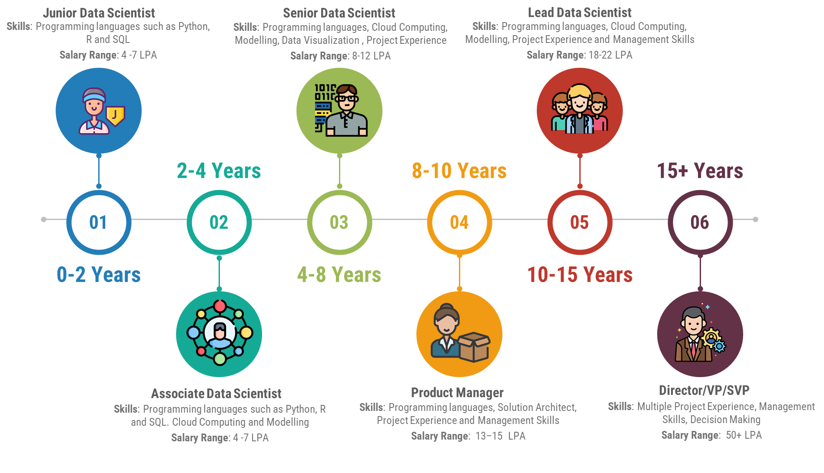

#### Image by [Author](https://www.linkedin.com/in/anishmahapatra/)

### Data Engineer

A Data Engineer in any organization is the backbone of any data system in the organization. In the majority of organizations, a data engineer is in charge of constructing data pipelines and ensuring that the data flow is right so that the information reaches the appropriate departments. The career progression for this would look like the  
  
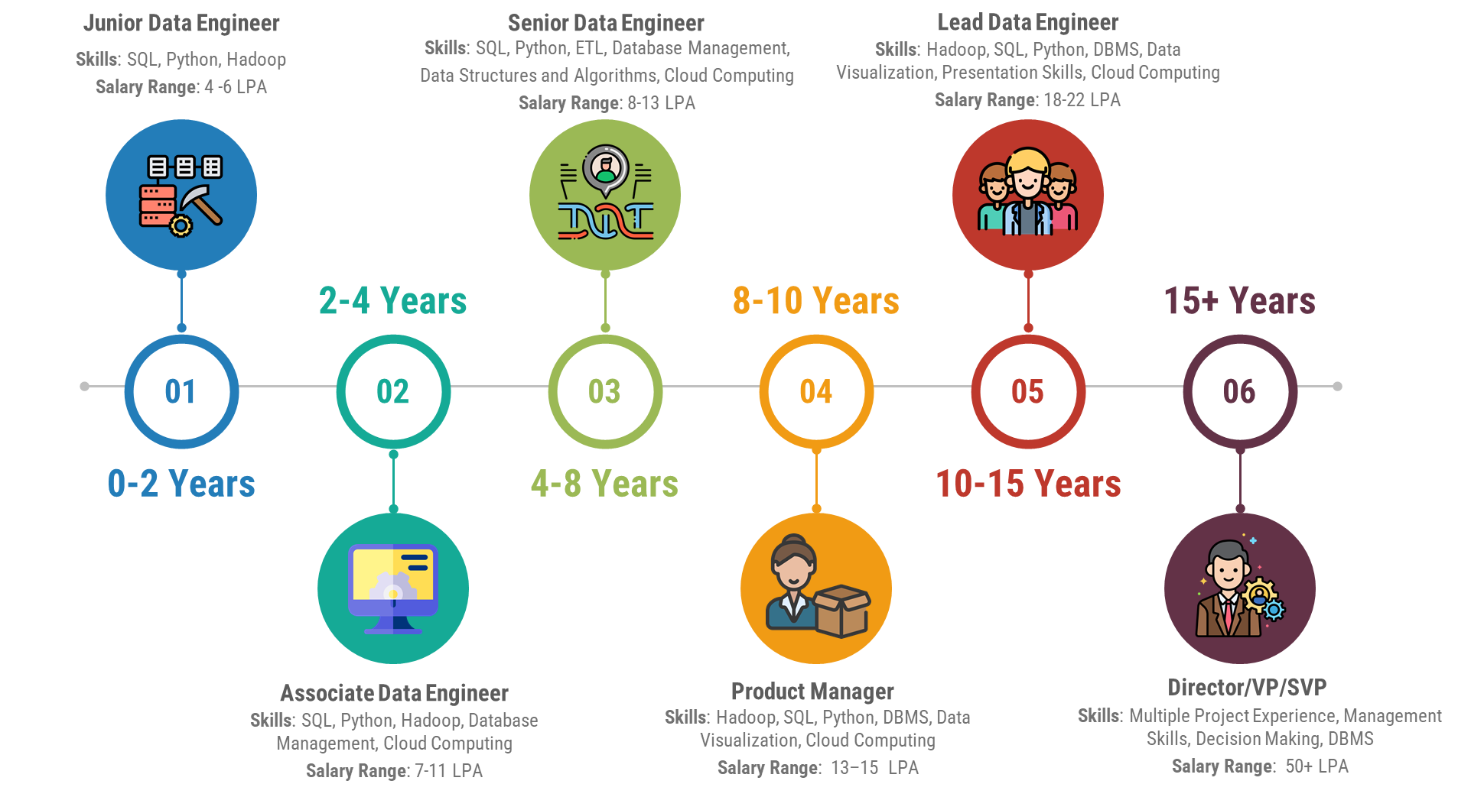

#### Image by [Author](https://www.linkedin.com/in/anishmahapatra/)

### Business Analyst

A business analyst is considered a bridge between the business and the data analysts and scientists. This role needs a strong understanding of business needs and requirements. A typical career path for a business analyst would look like the following  
  
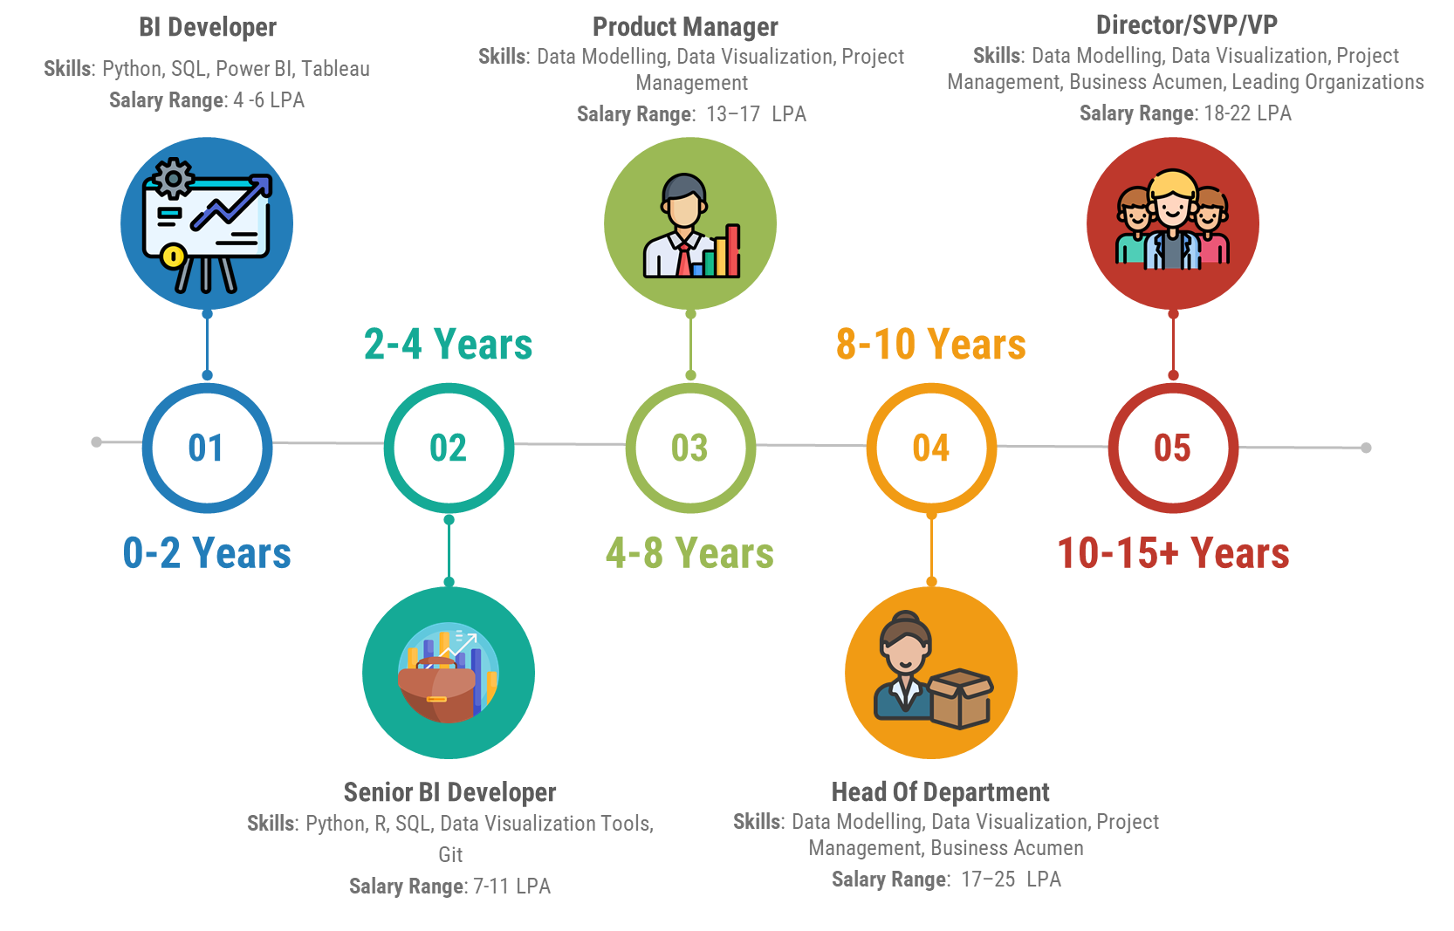

#### Image by [Author](https://www.linkedin.com/in/anishmahapatra/)

# Career Path and Salary for Artificial Intelligence

Though it is still a nascent profession, artificial intelligence is swiftly gaining recognition as a field that has the potential to transform the face of society. Here, we shall be talking about the process that one will be going through as an AI engineer, along with information and details about the compensation each of these roles offers.

## Getting started through ML/AI Engineer

As Artificial Intelligence is deeply connected with Machine Learning and Deep learning algorithms, an entry-level ML/AI Engineer will often design and build models on a team. A high level of education and technical experience is required for professionals in the field of machine learning engineering in order to advance their careers. Gaining experience is essential for success as a machine learning engineer. Working on real-world and theoretical models helps these engineers gain experience and show off their practical abilities. There is a lot of trial and error in this sector, just like in many other scientific and technical ones.

***Salary for an entry-level ML/AI Engineer in India***: 4-6 LPA

## Moving up the ranks

Consistent progression in work and gaining the required skillset will enable an ML/AI engineer to easily work their way up the ladder or Junior and Senior ML/AI Engineer. These engineers at a senior level develop mastery of deep learning and complex machine learning algorithms. The approach to becoming a Senior Machine Learning Engineer is to never stop pushing yourself to learn new tech and AI-related abilities. Being promoted to a senior level will benefit a machine learning engineer in numerous ways, including the respect they will command and the type of exciting work they will be expected to lead.

***Salary for a senior ML/AI Engineer in India***: 15-20 LPA

## Senior ML/AI Engineer. Where to proceed further?

Senior-level machine learning engineers can have a long and successful career where they are, contributing to the creation and implementation of intelligent systems that influence the daily lives of millions of people and shape the future. Senior ML/AI Engineers have every reason to remain in their current positions because, according to experts, the field is expanding and changing. As automation is viewed as the way for organizations across all industries to expand and enhance their operations, millions of Machine Learning Engineer jobs are expected to open up over the course of the next ten to fifteen years.

It is also possible for a senior ML/AI Engineer to progress further to become a Project Lead or move up the ranks of Head of AI department within the organization as well.

***Salary for a Project Lead/Head of Dept Engineer in India***: 25 LPA

# Data Science or Artificial Intelligence - Which is better?

Which is better data science or artificial intelligence? As we progressed through this article, we have understood the core of what happens through a Data Science pipeline with its wide array of applications and similarly with Artificial Intelligence. We have also understood how lucrative these two fields are both skill-wise and salary-wise. Now we come to a crucial question as we move towards choosing as to which one would suit you better for a career choice – data science or artificial intelligence which is better? For this, we will understand a little more about the difference between artificial intelligence and data science or the difference between ai and data science.

In this section, firstly, we shall bring forward the benefits and the skills that will be required to choose a career in **Data Science** through the below infographic:

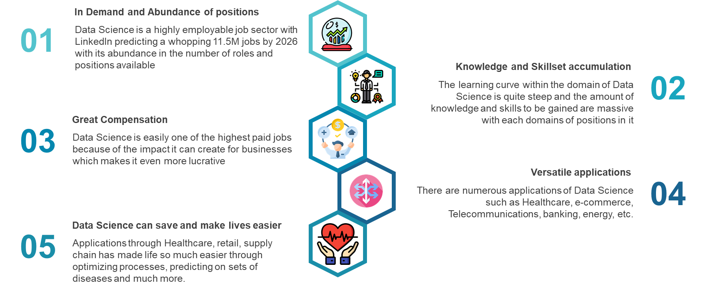

#### Image by [Author](https://www.linkedin.com/in/anishmahapatra/)

Major skills required for a career in Data Science are:

1. Mathematics and Statistics
2. Extensive use of tools such as Spark, Hadoop, Hive, etc. for handling big data
3. Programming tools - Python, SQL, R to start off with
4. Data Visualisation Tools: Power BI, Tableau, Qlikview
5. Knowledge of DBMS and how to use SQL with it
6. Strong understanding of Data cleaning, management, and data mining

Similarly, for **Artificial Intelligence**, we can look at the benefits in the field of AI in the following infographic.

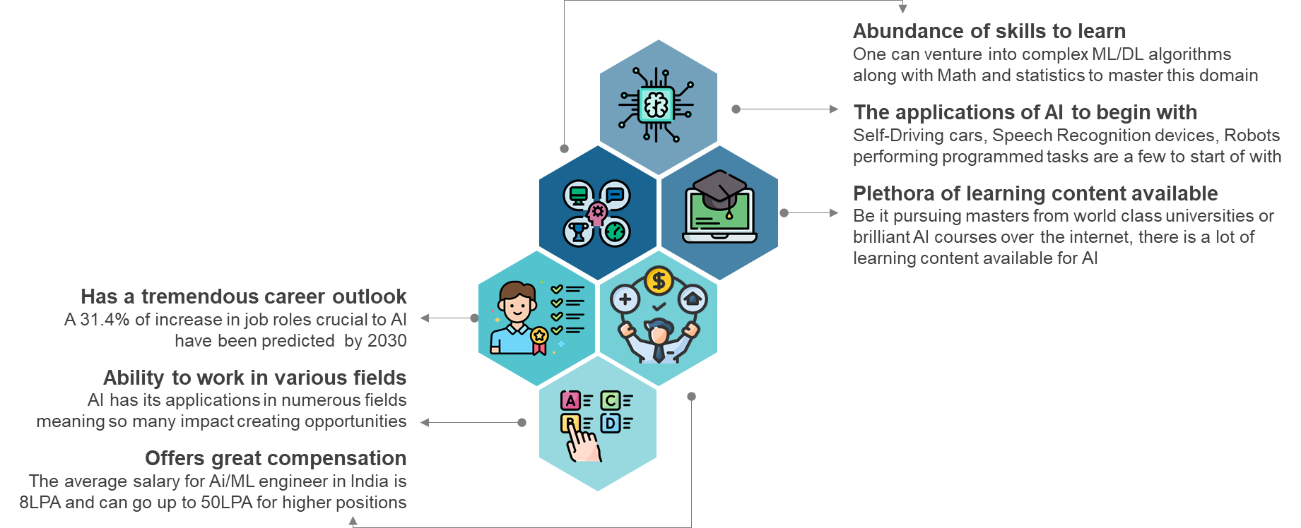

#### Image by [Author](https://www.linkedin.com/in/anishmahapatra/)

Major Skills required for a career in Artificial Intelligence are-

1. Strong foundation in Mathematics and statistics
2. Proficiency in programming skills
3. Knowledge in Machine Learning and Deep Learning algorithms such as image processing, NLP, computer vision, and neural network architectures
4. Data Visualisation

Now, this leads us to a very interesting crossroads as to which one would be better for a career choice for an individual. With an average salary ranging from 8LPA for data science and increasing to almost the range of 20-30 LPA with greater experience, it compares similarly to that of Artificial Intelligence roles within India, meaning there are many similarities in salary ranges for data science vs. artificial intelligence salary. It also continues to be difficult for the IT sector in India to hire the top experts in data science and AI. Although there is still a strong job market, it is advised that professionals update their abilities in both areas. This can be done by taking up artificial intelligence and data science course that are available on the internet.

Through this section, we were able to highlight benefits, mandatory skills required, and the market situation for both Artificial Intelligence and Data Science engineering job roles artificial intelligence and data science. The choice really comes down to you being able to choose which domain suits you and excites you better.

# Conclusion

In conclusion, we hope that through this article, you were able to understand the core of the two domains of Data Science and Artificial Intelligence and their applications. We also traversed through different job profiles one would get to see across these domains and how one would progress through each of the domains. While it remains an open choice for one to get into either data science or artificial intelligence, we see that each of these domains offers a plethora of opportunities in numerous ways, such as career path, compensation, and the ability to create huge impacts on many businesses, healthcare, and environmental issues.